In this documentation we will go over some basic functions you can use in Visual Studio Code.

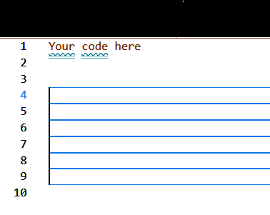**Basic Hotkeys:**

1. Text Movement Hotkeys:

Ctrl + Alt + Up/Down arrow keys: this will create a larger text cursor allowing you to type the same thing on multiple lines, or delete multiple things at the same time.

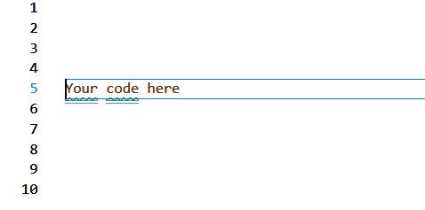

Alt + Up/Down arrow keys: This will move selected lines of code or wherever your cursor is(does not work with the larger cursor discussed above) just highlight whichever line of code you want to and use this hotkey to move it to wherever you wish!

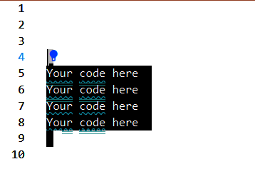

Shift + left click/Shift + Up/Down arrow keys: This hotkey will allow you to mass highlight to make your life easier, using it you can highlight large groups of code by clicking to a new line, either above or below your current cursor. You can also accomplish the same thing with the arrow keys rather than clicking.

1. 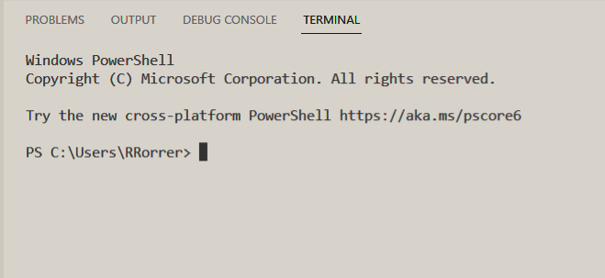Terminal Hotkeys:

New Terminal: Ctrl+shift+`: This will create a new terminal which acts like a command prompt inside of VSCode. This will allow you to do various things which we will discuss in a later section.

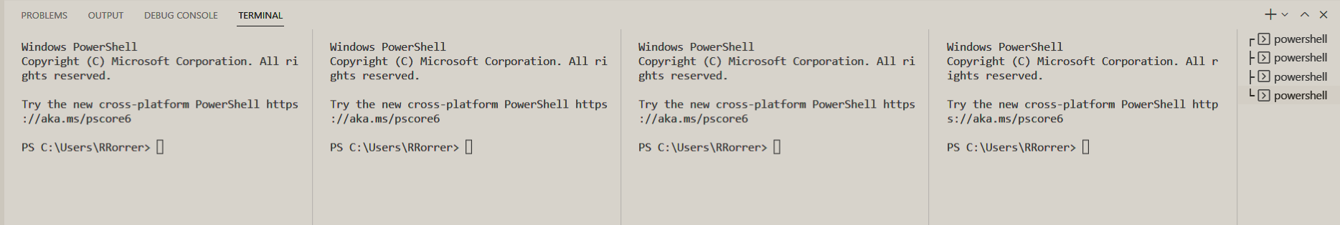New Split Terminal: Ctrl+shift+5: This will create a new terminal in split mode allowing you to have multiple command prompts open at the same time, they all work independently from one another.

**Terminals:**

1. 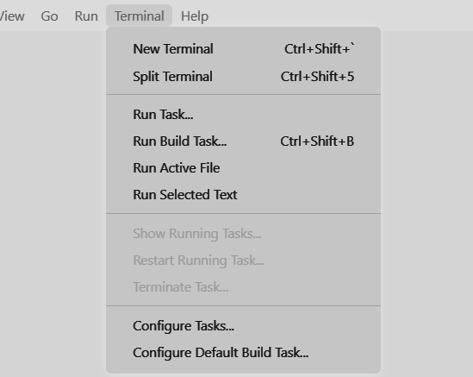Basic Terminals

Using the Terminal hotkey in section 1 OR using the terminal drop down menu and selecting “New Terminal “ will allow you to create a new terminal.

When you have a terminal open you’ll be able to do everything you can in the command prompt. It’ll allow you to not only keep everything organized, but it’ll save you a lot of time. Such as when installing node modules and running your applications.

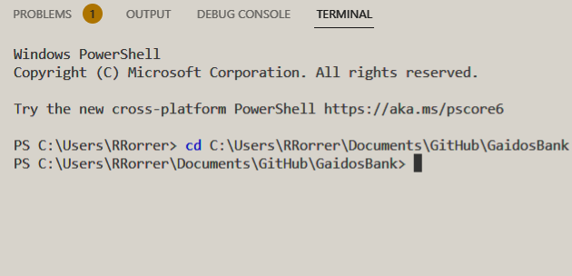

1. Split Terminals

When you open a new split terminal using the hotkey or the previously mentioned drop down menu you can access multiple terminals at the same time. This allows for multiple work streams, which is useful for a multitude of things.

You can run multiple files at the same time, pull from separate file paths, test websocket interactions with clients and hosts more easily, and even have separate outputs to test multiple lines of code.

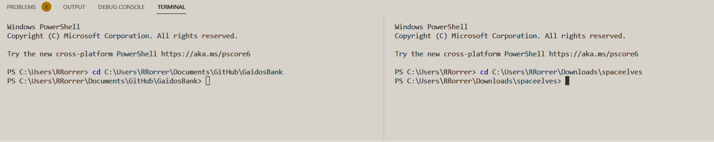 This is one of the more useful features inside of VSCode as it allows you to not only increase your workflow, but you can also more effectively test your programs.

**Extensions:** 

1. Themes

Upon the many extensions offered by VSCode themes are by far the most useless in terms of the functionality. Though they’re incredibly important to a lot of people as they create a comfortable workspace for both the mind and eyes.

There are many themes to play around with and finding the one you like is as easy as hitting install.

To install a theme or any extension you must first hit the bottom most icon on your left task bar. Once you access this you’ll be presented with a screen labeled extensions. Using the search bar right above where it says install and typing in “theme” will bring up a multitude of themes for you to try.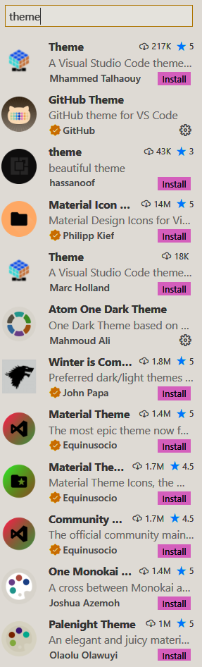

You can now hit the install button on any theme that tickles your fancy. You can do the same thing with any other extension you might be searching for such as a debugger for your specified web browser.

1. Extension uses

Extensions in general are the most useful VSCode feature and it would take 4 pages just to explain all the different possibilities. If you want and or need something you most definitely can get an extension for it.

Some of the many uses are debug tools, allowing you to debug your code directly inside of VSCode. Tools to help with game development inside of the Unity game engine. You can even get extensions that add snippets(essentially code shortcuts) to increase your workflow!

**Endnotes**

Overall VSCode is a direct upgrade from Atom in terms of functionality, the folks at Worse Company™ wish you the best of luck in your future with coding and VSCode.